CambridgeSoft Excel SAR Viewer 10.0 Guide

Revision History
Date | Revision | Description | Contributors
6/7/2009 | v.1 | Initial draft | David Gosalvez
6/10/2009 | v.2 | Revised missing sequence | David Gosalvez

Copyright © 2009 CambridgeSoft Corporation. Cambridge, Massachusetts.
All Rights Reserved

This document is the property of CambridgeSoft Corporation and is intended for internal use only. Reproduction or transmission of this document in any form, in whole or in part, without prior written permission of CambridgeSoft Corporation is prohibited.

Overview:
CambridgeSoft’s Excel SAR Viewer 10.0 is an addin that allows querying and displaying Oracle data from Microsoft Excel. It enables Excel to query the Oracle database using the schema information provided by the BioSAR Browser database (BIOSARDB). The addin communicates directly with the BioSAR database. It does not use the BioSAR Browser application or the ChemOffice WebServer middle tier. Excel SAR Viewer requires the presence of the Oracle client to establish a direct SQLNet connection to the target Oracle database.

Prerequisites:
Client:

- Microsoft Excel 2000 or 2003
- ChemDraw Pro or Ultra
- ChemDraw for Excel Addin
- Oracle 10g Client
- Oracle OLEDB Provider 10.2.0.20

Application Server:

- ChemOffice WebServer 10.0
- BioSAR Browser 10.0

See ChemBioOffice Enterprise 10.0 Installation Guide for detailed requirements and instructions on how to setup and configure BioSAR Browser 10.0

Database Server:

- Oracle 10g
- CambridgeSoft Oracle Cartridge 11.0.1
- CS_SECURITY schema
- BioSARDB schema

See ChemBioOffice Enterprise 10.0 Installation Guide for detailed requirements and instructions on how to setup and configure the database for BioSAR Browser 10 operation.

Installation
Client:

CambridgeSoft Excel SAR Viewer is implemented as an addin to Microsoft Excel. It is comprised of a single (.xla) file which must be copied to the client machine and referenced from the Excel Addins management dialog.

- Copy the CSXLSAR.xla file provided with this distribution to the location where other CambridgeSoft application were previously installed. By default this would be the C:\Program Files\CambridgeSoft folder.
- Launch MS Excel
- Click Tools > Addins Excel menu item
- Verify that the ChemDraw/Excel 10 addin is checked. If the addin is not yet enabled, refer to the ChemDraw or ChemOffice documentation for specific instructions on how to enable and use it.
- Click the browse button and navigate to the location where the CSXLSAR.xla was copied in step 1 above.
- A new entry “SAR Viewer” will appear in the list of addins. This entry should be checked.

Application Server:

No installation tasks are required on the middle tier server, beyond the standard installation of BioSAR Browser 10.0

Database Server:

All users connecting to the BIOSARDB schema via the Excel SAR Viewer addin must have appropriate permissions to read the Oracle tables used to populate the SAR table and must also have appropriate read/write permissions on the BIOSARDB tables. The BioSAR Browser schema manager takes care of granting all required permissions to its users and roles. It is therefore highly recommended to use BioSAR Browser user credentials when directly connecting to the database via the Excel SAR Viewer addin. The only additional privilege required by the addin is the ability of end-users to insert data into the BIOSARDB CSDOHitlist and CSDOHitlistID tables. The simplest way to guarantee this privileges is to grant them to the lowest level BioSAR Browser role as follows:

- Connect to the target Oracle instance via SQLPlus:

C:\SQLPlus.exe BIOSARDB/orable@YourServiceName

- GRANT INSERT on CSDOHitlist to CSS_USER;
- GRANT INSERT on CSDOHitlistID to CSS_USER;
- GRANT SELECT on CSDOHITLISTID_SEQ to CSS_USER;

System Configuration
The SAR Viewer addin relies on the BioSAR Browser “Table Organization” feature to determine which tables should be visible in Excel. To access the Table Organization tree:

- Use a web browser to log into the BioSAR Browser application with a user that has sufficient privileges to access the Schema Management link.
- Click the Schema Management link for the home page.
- Within Schema Mangement, click the “Admin” menu item.
- Select the Mamange > Organization... option

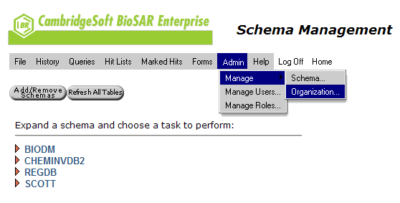
The table organization dialog should appear and look similar to this:

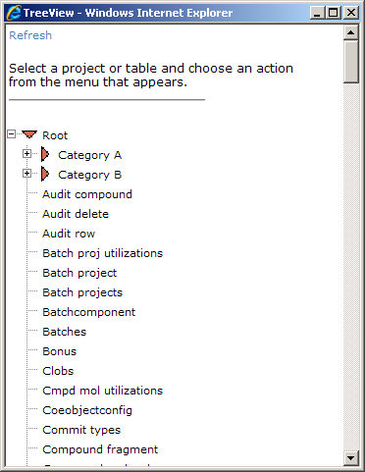

Note that the actual tree node and table names will differ depending on the target system.

In order for the Excel addin to see tables, they must be placed within a special organization folder called “Excel SAR Viewer”. To add such a folder to the tree, select the Root node and click on the “New” link. Enter the node name exactly as it appears below (including capitalization):

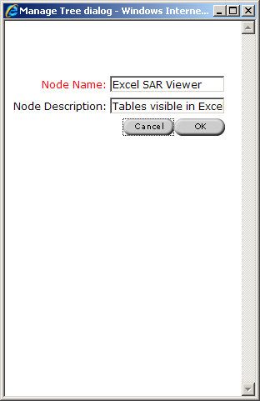

The first table listed under the Excel SAR Viewer folder will be assumed to be the primary SAR table containing the Chemical Structures and structure identifiers. In the example below, the primary SAR table is called “Compounds”, but it can be given any desired name:

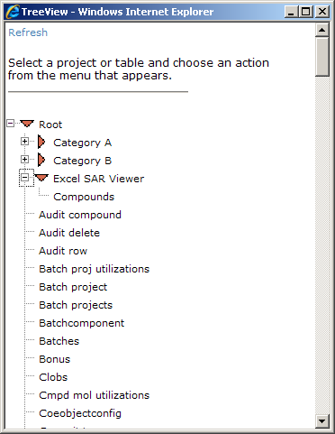

Assay tables can be organized into one or more folders contained within the Excel SAR Viewer folder. For example, below are shown three folders created to contain different types of assays. Appropriate assay tables have been placed within each folder:

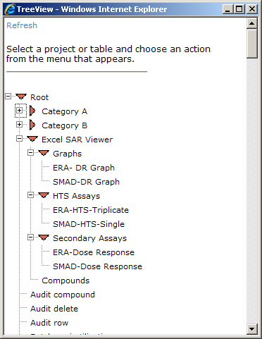

After performing this table organization, a user connecting via the Excel SAR Viewer addin will be able to see the tables contained within the Excel SAR Viewer folder provided that following conditions are met:

- The user has permissions to see the data on the tables
- There is at least one Primary SAR table directly under the Excel SAR Viewer folder
- If there is more than one table at that level, the one shown first in the tree is considered the primary table.
- There is at least one assay table in a subfolder
- If there is more than one table at this level, the one shown first in the tree is considered the primary assay table
- There is a parent-child relationship between the primary SAR table and the first assay table.
- All other assay tables must the same relationship to the parent table.

Tables that do not follow the above rules will not be visible in Excel, even if they are visible in BioSAR.

Creating a SAR Table in Excel

- Launch Excel
- Click a ChemOffice 10 Sheet by using the “New ChemOffice Worksheet” tool bar icon or menu item
- On the SAR Viewer toolbar select SAR Setup >

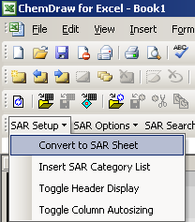

- A basic SAR table will be auto-generated using the Structure and Linink field for the primary SAR table.
- The third column of the table will be ready to choose a category, table, and column to display.
- To add additional SAR columns, select the first row of the desired column and cick the Insert SAR Category List option from the SAR Setup menu

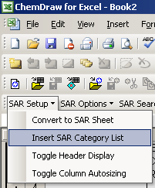

- Use row number 4 to enter query criteria for the desired column or columns
- Use the Replace All Results option in the SAR Search menu to initiate the query

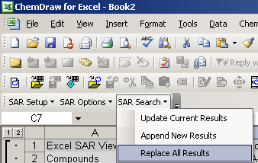

- Results for the selected column are displayed in the Excel sheet
